Wazaran Work Flow

Manually Sales Order
Step 1
Take Order 2

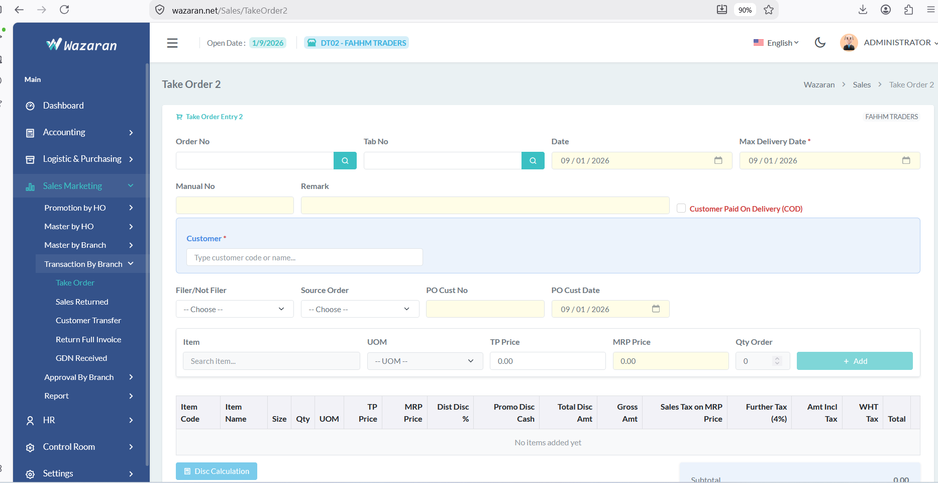
10
9
8
7
6
5
4
1
2
3

- Sales Marketing
- Transaction By Branch
- Take Order
- Tick if invoice create on Cash
- Enter customer code / name
- Choose PO
- Enter PO :123
- Add item code or name
- Choose UOM: CTN / PCS
- Add QTY ORDER

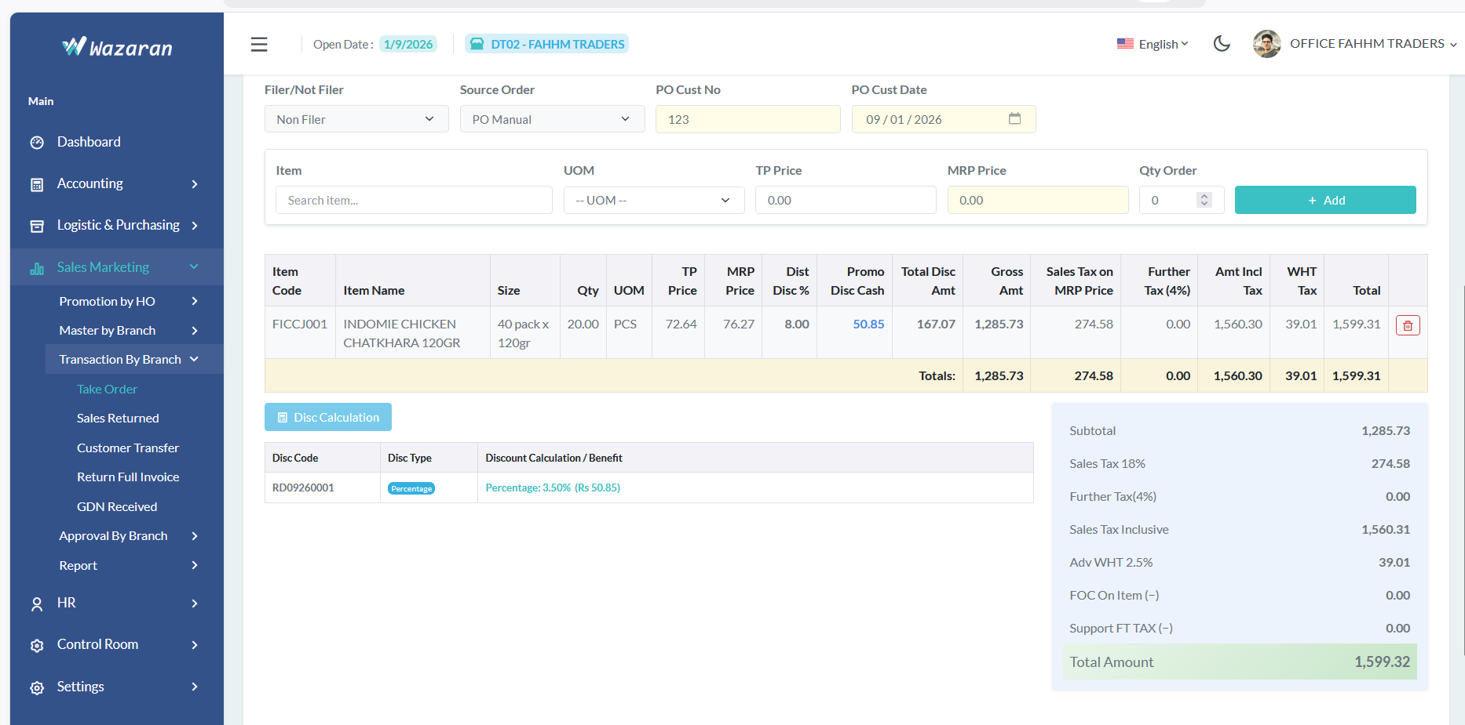
12
11

- Add button
- Click on Dis Calculation

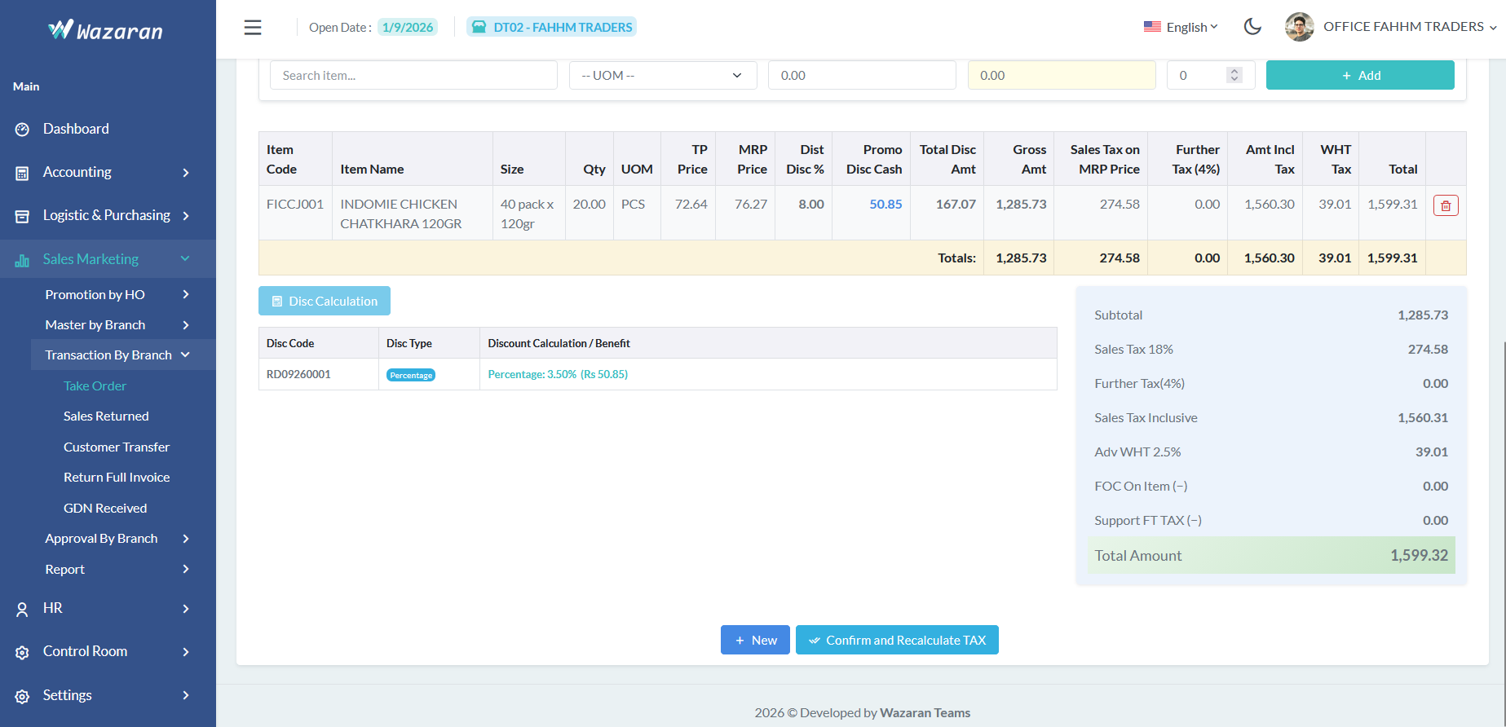
13

- Confirm and Recalculate Tax
- After Confirm and Recalculate tax show Save Button Save it

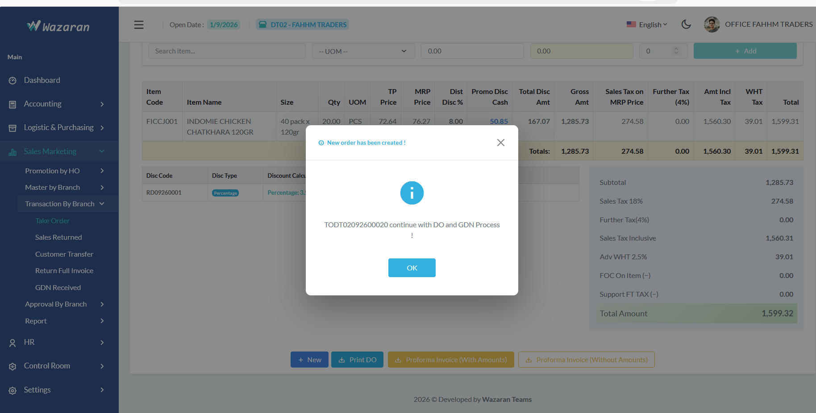
15
- Pess ok
- If you have new order press New button else you want to finalize this order Go step 2

Step 2
Good Delivery Note Customer

1
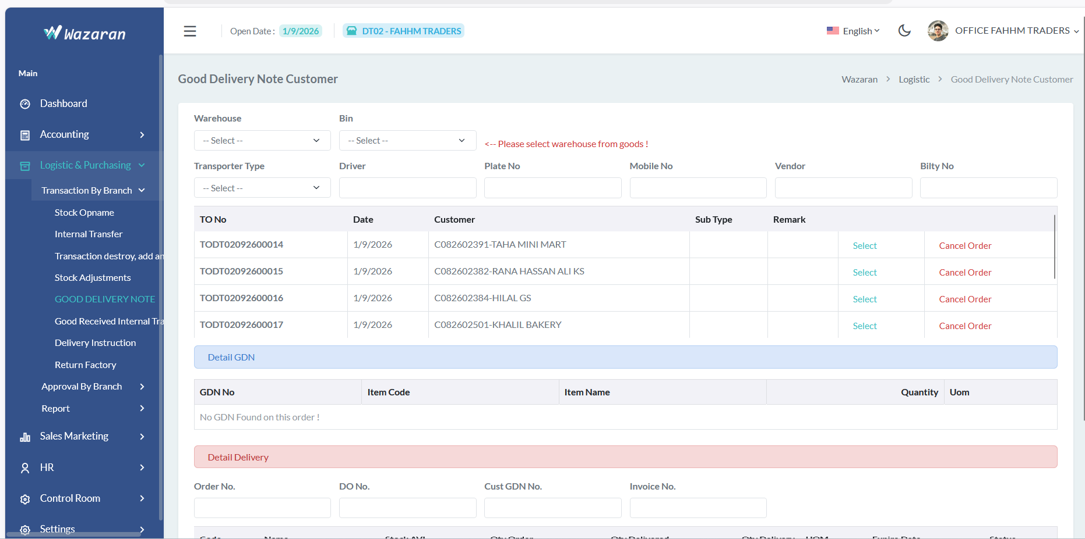
9
8
7
6
5
4
33
23
- Logistic & Purchasing
- Transaction By Branch
- Good Delivery Notes
- Select Warehouse like your Distribution name
- Select Bin : GS=> Good Stock
- Transport Type
- Select Drive name
- Enter mobile no
- Press “Select “ Button

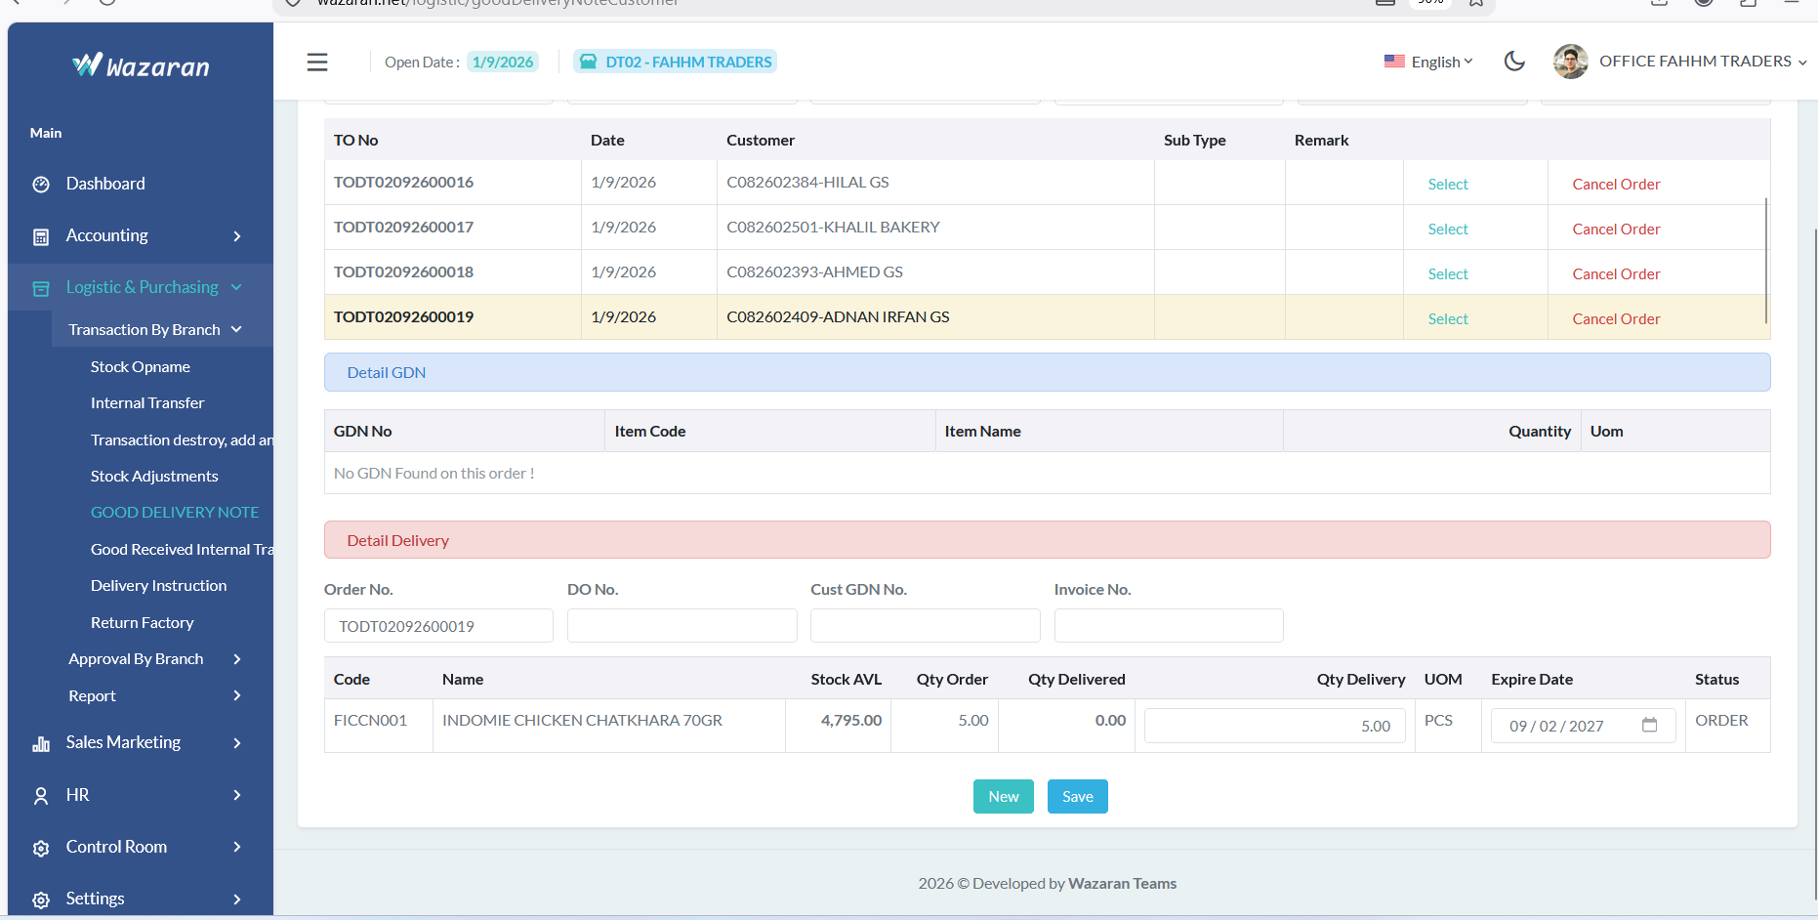
10

- Save

Step 3
Delivery Instruction

GDN Received
Step 1
1
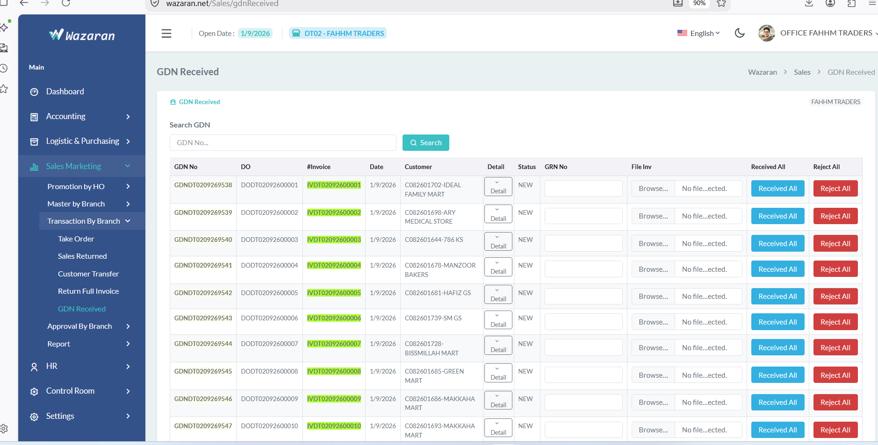
7
6
5
4
3
2
- Seles Marketing
- Transaction By Branch
- GDN Received
- Search GDN NO
- ADD GDN NO
- Browse same invoice /GDN Upload
- Press Received All Button
Done

Payment Received
Step 1

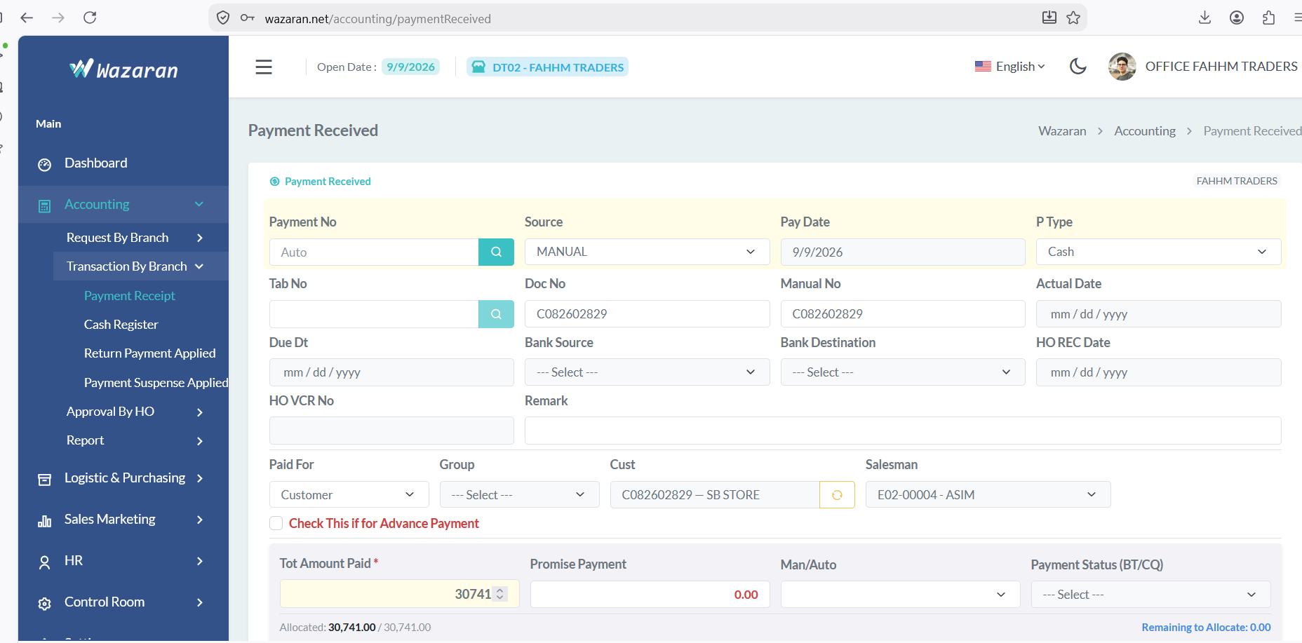
8
7
6
5
4
1
2
3
9
- Accounting
- Transction by Branch
- Payment Receipt
- Select Source Manual / Tab,
- Select P Type : Cash / Cheque /Bank Transfer
- Doc No / invoice no
- Manual No
- Cust no
- Add total amount Paid

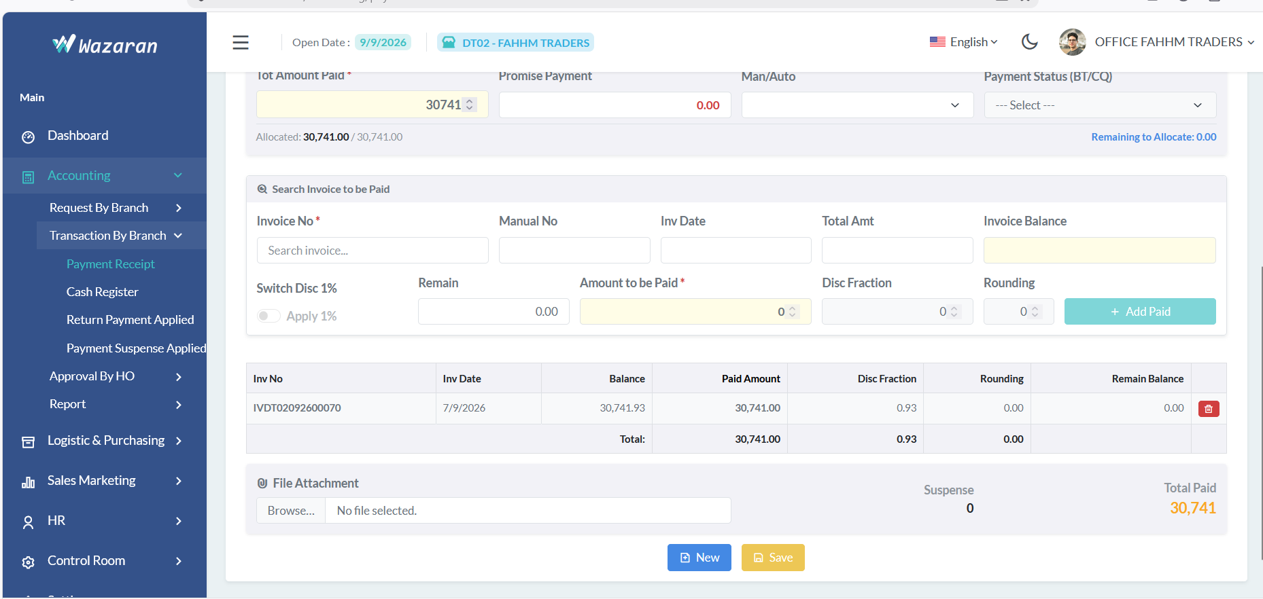
1069151

- Click here to find invoice, when click invoice show auto select invoice
12
11
- Click on addPaid Button
- Then Click Save Button

Daily Closing

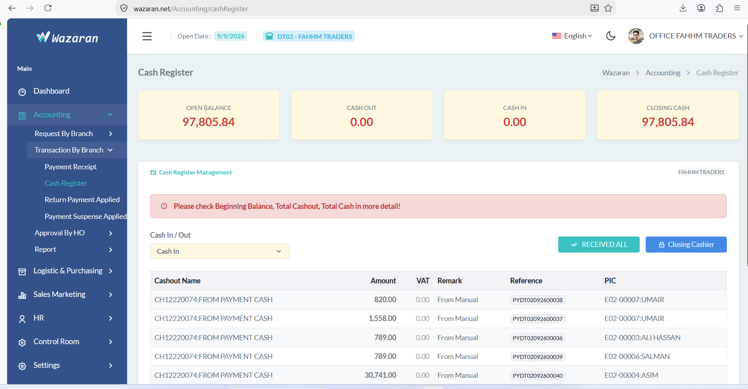
5
4
2
1
3
- Accounting
- Truncations By Branch
- Cash Register
- Click on Received All Button
- Then Click on Closing Cashier Button

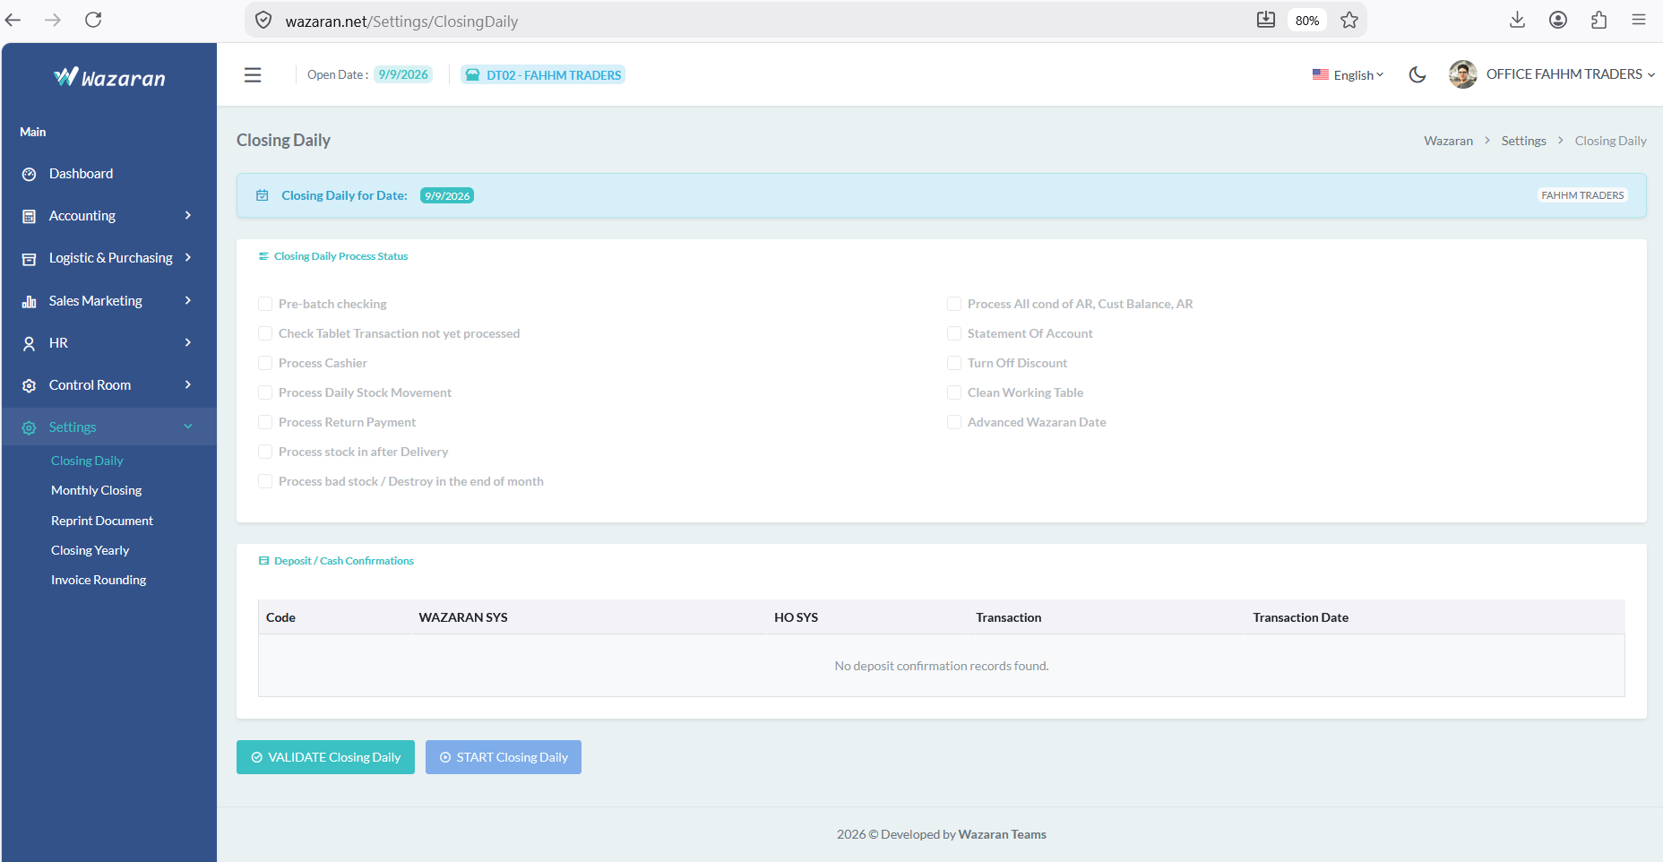
3
2
1

- Settings
- Closing Daily
- Validate Closing daily
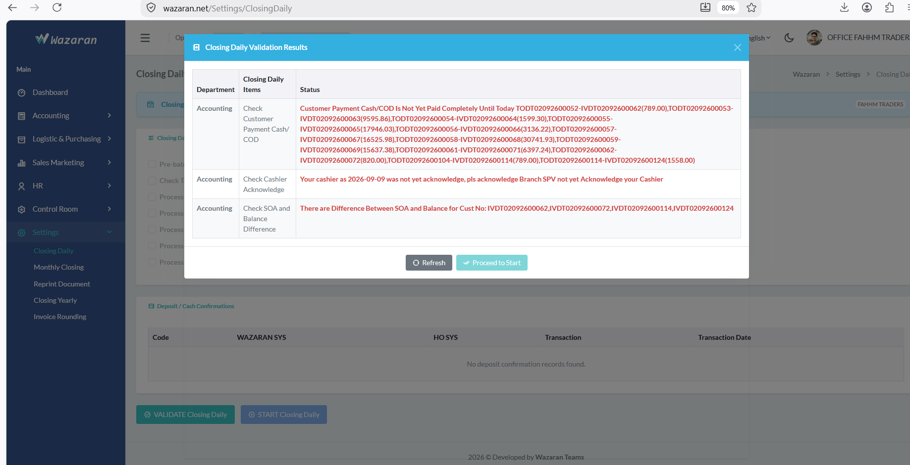
2
1
- Resolved all pending
- Processed to start

